Homework July 27

Write a JavaScript function to check whether an input is a string or not.  
Example: isString("JavaScript")  
Result: true

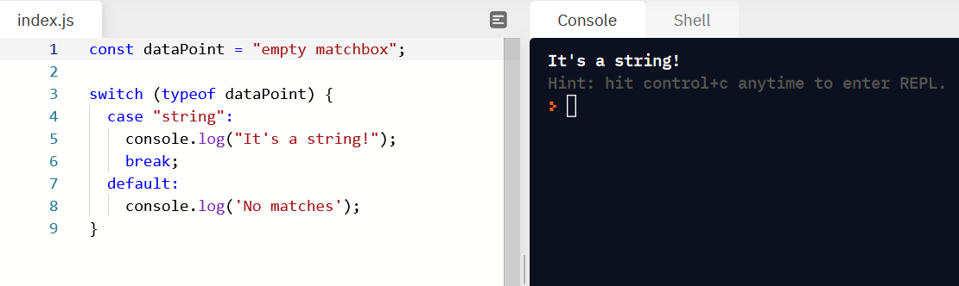

Write a JavaScript function to extract a specified number of characters from a string.  
Example: extraction("Hello there", 5)  
Result: "Hello"

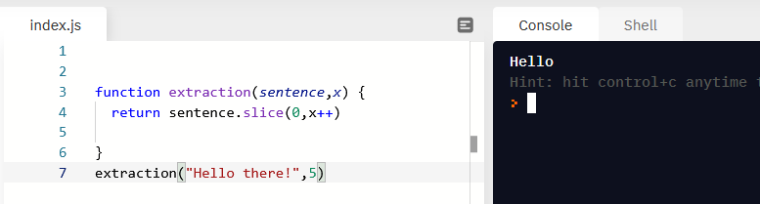

Write a JavaScript function to capitalize the first letter of each word in a string.  
Example: capitalize("javascript is a cool language")  
Result: "Javascript Is A Cool Language"

